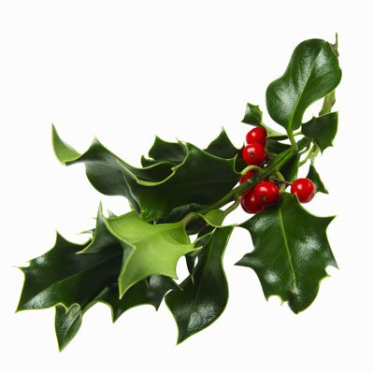
2022 Mistletoe Craft & Gift Sale
Application:

Name: ____________________________________________________________
Full Address: ____________________________________________________________
City: _______________________Postal Code: _____________________
(BAS will no longer do mail outs due to the rising cost of postage, provide your email address to receive notifications of upcoming applications.)
Email: ____________________________________________________________
Phone: ____________________________________________________________

Description of Crafts or items to be sold:
________________________________________________________________________________________________________________________________________________________________________________________________________________________________________________________________________________________________________________________________________________________________________

_______ Booth @ $150.00 x 5% GST_______ = $_______ (A)

_____ Extra Table(s) @ $5.00 x 5% GST ______x 6% PST _______ = $______ (B)

Total owed (A) + (B) $________

PST Charged ONLY on the table rental

( ) Yes I do require provided table (only ONE 8ft table provided per booth + 2 chairs)
( ) No, I do NOT require a table.
( ) No. of name tags required for booth staff

EXTRA TABLES AVAILABLE FOR $5.00 EACH + Taxes

PAYMENT IN FULL MUST ACCOMPANY THIS APPLICATION.
NO POST DATED CHEQUES WILL BE ACCEPTED.

VISA#: ______________________________________ Expiry Date: ________________
M/C#: ______________________________________ Expiry Date: ________________

Make Cheque Payable to:
The Battlefords Agricultural Society
P.O Box 668
North Battleford, SK, S9A 2Y9
Phone: (306) 445.2024 Fax: (306) 445.3352
Email: Jocelyn@agsociety.com
etransfer: payments@agsociety.com

Date: ________________________________________
Signature: _____________________________________

Receipt #: ____________ (For Office Use)

Invitation to Exhibit
To ensure quality throughout the Show, every attempt is made to include a wide variety of crafts and gifts.
Applications will be reviewed and applicants will be selected by the committee. Applications that are rejected will have their fees FULLY refunded.

Demonstrations
Booth demonstrations by artists are encouraged.

Exhibit Space
Single booths are 10’ x 10’. All spaces are draped on three sides with one 8’ x 30” table and two chairs provided.

One power outlet is provided in each booth. You must bring your own extension cords.

Exhibitors are responsible for their own decorating including lighting, extension cords and all necessary tools such as hammers, scissors, tape, screwdrivers, etc. Exhibitors are also responsible for their own liability insurance.

If necessary, we have the ability to comply with Saskatchewan Health Authorities directives in order to facilitate social distancing.

Acceptance is based on committee selection. Booth fee MUST accompany application and will be returned if your application is rejected. Booths are not transferable. A $50.00 non – refundable processing fee will be applied for all cancellations received by Sept 10, 2022. No refunds will be given for any cancellation after SEPTEMBER 10, 2022.

If for reasons due to COVID19 either party must cancel, the cancellation policy will be waived.

Exhibits are to be staffed by the owner or a representative at all times when open to the public for reasons of security and information concerning the display. Displays shall NOT diminish because of sales. Exhibitors are expected to display ONLY what is indicated on their application. The Battlefords Agricultural Society and the Mistletoe Committee assume no responsibility for safety of exhibits, accidents, or other related problems. The Building is armed and secured Friday night and Saturday after close.

*** In order to prevent duplication of booths, please provide a full description of booth displays, crafts, and products. ***
*** BOOTH FEE WILL NOT BE REFUNDED AFTER SEPTEMBER 10, 2022***

PARTICULARS

SET-UP: HOURS OF OPERATION:
Fri., Nov. 5 8:30 am – 9:00 pm Sat., Nov 5 11:00 am – 6:00 pm
Sat., Nov. 6 8:00 am – 10:00 am Sun., Nov 6 11:00 am – 4:00 pm

TAKE DOWN: Sun., Nov. 6 AFTER 4:00 pm
To enforce a quality show tearing down early will result
in FINES of $50.00 per ½ hour.

