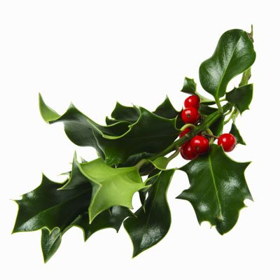**2025 Mistletoe Craft & Gift Sale**

**Application:**

Name: ____________________________________________________________

Full Address: ____________________________________________________________

City: _______________________Postal Code: _____________________

(BAS will no longer do mail outs due to the rising cost of postage, provide your email address to receive notifications of upcoming applications.)

Email: ____________________________________________________________

Phone: ____________________________________________________________

Description of Crafts or items to be sold:

________________________________________________________________________________________________________________________________________________________________________________________________________________________________________________________________________________________________________________________________________________________________________

**_______ Booth @ $150.00 x 5% GST_______ = $_______ (A)**

**_____ Extra Table(s) @ $5.00 x 5% GST ______x 6% PST _______ = $______ (B)**

**Total owed (A) + (B) $________**

**PST Charged ONLY on the table rental**

( ) Yes I do require **provided table** (only ONE 8ft table provided per booth + 2 chairs)

( ) No, I do NOT require a table.

( ) No. of name tags required for booth staff

**EXTRA TABLES AVAILABLE FOR $5.00 EACH + Taxes**

***PAYMENT IN FULL MUST ACCOMPANY THIS APPLICATION.***

***NO POST DATED CHEQUES WILL BE ACCEPTED.***

VISA#: ______________________________________ Expiry Date: ________________

M/C#: ______________________________________ Expiry Date: ________________

CVV # : ________________________

**Make Cheque Payable to:**

The Battlefords Agricultural Society

P.O Box 668

North Battleford, SK, S9A 2Y9

Phone: (306) 445.2024 Fax: (306) 445.3352

Email: Leanna@agsociety.com

etransfer: [payments@agsociety.com](mailto:payments@agsociety.com)

Date: ________________________________________

Signature: _____________________________________

Receipt #: ____________ (For Office Use)

**Invitation to Exhibit**

To ensure quality throughout the Show, every attempt is made to include a wide variety of crafts and gifts.

**Applications will be reviewed and applicants will be selected by the committee. Applications that are rejected will have their fees FULLY refunded.**

**Demonstrations**

Booth demonstrations by artists are encouraged.

**Exhibit Space**

Single booths are 10’ x 10’. All spaces are draped on three sides with one 8’ x 30” table and two chairs provided.

One power outlet is provided in each booth. You must bring your own extension cords.

Exhibitors are responsible for their own decorating including lighting, extension cords and all necessary tools such as hammers, scissors, tape, screwdrivers, etc. Exhibitors are also responsible for their own liability insurance.

**If necessary, we have the ability to comply with Saskatchewan Health Authorities directives in order to facilitate social distancing.**

**Acceptance is based on committee selection**. Booth fee **MUST** accompany application and will be returned if your application is rejected. Booths are not transferable. No refunds will be given for any cancellation after SEPTEMBER 30, 2025.

Exhibits are to be staffed by the owner or a representative at all times when open to the public for reasons of security and information concerning the display. Displays shall **NOT** diminish because of sales. Exhibitors are expected to display **ONLY** what is indicated on their application. The Battlefords Agricultural Society and the Mistletoe Committee assume no responsibility for safety of exhibits, accidents, or other related problems. The Building is armed and secured Friday night and Saturday after close.

**\*\*\* In order to prevent duplication of booths, please provide a full description of booth displays, crafts, and products. \*\*\***

**\*\*\* BOOTH FEE WILL NOT BE REFUNDED AFTER SEPTEMBER 30, 2025\*\*\***

**PARTICULARS**

**SET-UP: HOURS OF OPERATION:**

**Fri. Nov. 7th 8:30 am – 9:00 pm Sat. Nov 8th 11:00 am – 6:00 pm**

**Sat. Nov. 8th 8:00 am – 10:00 am Sun. Nov 9th 11:00 am – 4:00 pm**

**TAKE DOWN: Sun., Nov. 9th AFTER 4:00 pm**

**To enforce a quality show tearing down early will result**

**in FINES of $50.00 per ½ hour.**